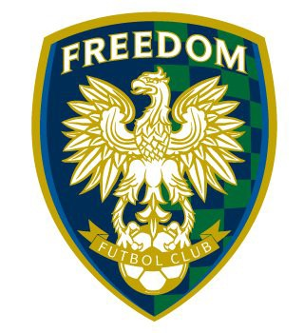

Dear Future Sponsor:

Please allow this letter to introduce you to Freedom Futbol Club (Freedom FC) and our 3rd Annual Golf Tournament November 10, 2017 for which we are seeking your support.

Freedom FC is a locally based competitive youth soccer organization, dedicated to instilling the love of soccer through the education and development of youth players, committed to creating winners on and off the field. We currently have 41 teams, with over 450 players. Freedom FC families come from Chino and Chino Hills and its surrounding areas – Whittier, Walnut, Diamond Bar, Claremont and Ontario. We are looking for community support to assist us, with the proceeds from the tournament going to the purchase of soccer equipment (e.g., goals, nets, cones, pennies, soccer balls) and sponsoring select scholarship applicants.
We think highly of your establishment and think that this is a great opportunity for your company to receive additional exposure in the community, while helping to support a worthy cause. We offer two levels of sponsorship and as a participating sponsor, you will receive:

- $1000 Premier Sponsorship
  - A foursome
    - Includes 18 holes, cart, breakfast, lunch, and raffle/auction
  - Long Drive & Closest to Pin
  - One (1) hole sponsorship, with signage
  - Reference in all promotional materials
  - Opportunity to include branded item in player gift bags

- $500 Gold Sponsorship
  - Long Drive & Closest to Pin
  - One (1) hole sponsorship, with signage
  - Reference in all promotional materials
  - Opportunity to include branded item in player gift bags

- Any promotional items to be included in gift bags

We appreciate your consideration and look forward to hearing from you soon. If your company wishes to be a sponsor please contact Scott Schneider at 909-226-8757 or sschneider@freedomfc.org.

Sincerely,

Scott Schneider
Vice President
Freedom FC
sschneider@freedomfc.org

